Norfolk & Waveney Local Optical Committee

# **Annual General meeting 5 June 2024**

# Minutes

The 2024 Annual General Meeting of the Norfolk & Waveney Local Optical Committee was held at Aldiss Park, Norwich Road, Dereham. Norfolk NR20 3PX and was called to order at 19:30 on 5th June 2024 by Mrs. Deborah Daplyn. (Chair)

## Present: Ed Adkins, Robert Amey, Annette Ball, Hannah Castley, Charlotte Berryman, Elizabeth Bunn, Belinda Chincharo, Deborah Daplyn, Ali Ganiwalla, Michelle Horn, Roger Lee, Joanne Loades-Almond, Niall O’Brien, Dan Rosser, Ian Sinha, Linda Vernon-Wood, Peter Hutchinson (Administrator),

## Apologies for Abesence: Clare Campbell, Julien Nelson, Observer: Zoe Richmond – LOCSU Clinical Director, - Returning Officer for the Election

## Declarations of Interest: None

## Business

1. Mrs. Deborah Daplyn welcomed those present to the Norfolk & Waveney Local Optical Committee Annual General Meeting for the year ended 31st March 2024 and congratulated everyone for making the effort to attend.
2. **The Draft Minutes** from the AGM held on 7th June 2023 were uploaded to the NWLOC website on 6th May 2024 where they were available for download. No comments or objections had been received by the committee so it was proposed they be taken as read. Elizabeth Bunn proposed they be accepted as a true and accurate record, seconded by Ian Sinha. The minutes were duly approved and signed.
3. **Chair’s Report**

This year, I have been sharing the Chair-ship with Michelle Horn, who will take over from me shortly, but I have been given the job of writing this report on behalf of both of us.

We have a good relationship with the ICB’s primary care team and are in regular dialogue with them. We are trying to find solutions on two fronts currently. The first is the ongoing nonsense of nhs mail. The rule is that if your business has 10 practices or less, that you will be given a business mailbox and a number of individual addresses are linked to that. In practice, all mail should be sent from the practice mailbox, so as long as everyone that needs to can access it, the problem is solved. If you are over 10 then for some bizarre reason, you cannot have an nhs mail address and should use EGRESS instead. Thank you to all those who replied to my call earlier this year to tell me of their situation and I think we can safely say from that, that EGRESS doesn’t work well. We are searching for another solution but don’t expect any soon. The second piece of work lies with the workforce team who are trying to find us some funding and support for upskilling via further qualifications, more news to come in due course.

Sadly, the team running our enhanced services have come to the end of their project and a new team have yet to be put in place after ICB restructuring. This means that we are currently treading water as far as enhanced services are concerned, although everything current has been rolled over for another year at least. We hope a new team will be put in place soon so that we can discuss improvements to our existing services and possible new opportunities.

Primary Eyecare Services have promised us that the long awaited new glaucoma module should be available very soon and we hope to get the suspect glaucoma and OHT monitoring service back on track as soon as it is up and running.

The project team ended with the new cataract contract which came in to place over the early Spring. Please be aware that brings some changes for each practice to consider:

1. There is a new cataract referral form for use in the West and Central areas. Please use this form and destroy any previous template forms. A reminder that all referrals for cataract must be made to the relevant Referral Management Service (RMS).
2. For those of you in the East where there is no RMS, please continue to refer as you currently do. Remember that you MUST offer choice to the patient at the point of referral OR refer them to their GP for this to be done.
3. The new cataract contract stipulates that any patient, who is deemed suitable, must be discharged back to the community for their post op assessments. This has led to a big increase in the numbers being sent out, so if your practice does not currently offer this, please seriously consider why not. It is much better for the patients to be seen by their referring practice and is useful extra income for minimal extra work.

We hope that you have been able to join one of our organised CPD events, and found them enjoyable, worthwhile and useful. We will continue to put on a full calendar of events, information on upcoming events can be found on our website.

Once again, I would like to thank the work of the committee without which, none of this would be happening at all. Behind the scenes, there is an enormous amount of diplomacy and scrutiny that goes on, some of which never sees the light of day and goes unnoticed by the rest of the profession. It still requires skill and dedication and we all owe the committee a debt of gratitude. I know that the last thing that you want to do after a day at work is fill in surveys or respond to emails but please remember we are your representative committee. It is very hard to represent you, if you don’t tell us what you want or where the problems lie, so please stay in touch. Please help us to help you, join the website, keep your details up to date and engage with us if you can.

Michelle and I wish you a healthy and prosperous rest of 2024.

Deborah Daplyn

Co-Chair. NWLOC

1. **Current Status – Chair Report**
   1. NWLOC has a good relationship at present with the N&W ICB Primary Care Team where discussions continue in trying to resolve the problems in obtaining NHSmail accounts.
   2. The ICB has funds available support the optometrists wishing to obtain and Independent Prescribing qualification. Practitioners present were asked to publicise this opportunity amongst their staff and other practices.
   3. The Primary Care Team recognizes the difficulties experienced for all Primary Care disciplines in recruiting and retaining staff in this area. In an attempt to address this The IBB will be running job fairs and producing videos to promote the opportunities in each profession in the Norfolk & Waveney area. To introduce this all optometrists are invited to attend a seminar at the Wensum Valley Golf Club on 16th July. The chair emphasized the need for a good attendance by optometrists to show support for the scheme and a willingness to participate in addressing a difficult area of practice life.
   4. ICB Enhanced Services are not functional at present as anew team is being formed.
   5. The Central Referral Management Service (CRMS) is scheduled to be closed down on 30th September as part of ICB cost savings. The Chair has written a strongly worded letter of complaint in which she explained that the GOS Sight Test Fee does not cover the cost of provision and therefore optometrists cannot make direct referrals involving the additional work of Choose & Book. If the work of the CRMS cannot be restored then Optometrists will be advised to refer all patients to their GP. It was concluded that this message will be communicated to the LMC if a meeting with the ICB cannot provide an acceptable solution to the problem. All present were asked to spread this information to as may practitioners as possible and details will be uploaded to the website.
2. **Secretary’s Report** Another year and more changes – plus an election on the horizon!

One of the major issues facing healthcare is funding. In essence, the NHS is tightening their purse-strings as a result of costs incurred in dealing with the Covid crisis 4 years ago.

The biggest imminent change is the imminent closure of the Norfolk Regional Management Service, which handles cataract referrals. This service came about, in order to offer Choose and Book when referral patients. There is still a requirement to offer patient choice - As a result, we will either be expected to offer patient choice when referring or send all referrals via the GP for them to offer it. Obviously, community optometrists aren’t going to be very happy to take on the extra time and administration as part of an already badly underfunded service, so it remains to be seen what fees can be negotiated with a cash-strapped ICB to determine which way this will take. It does seem pretty daft to shut down a system that works so well and will no doubt turn out to be a false economy like so many other cost-cutting decisions.

Politicians of all the parties seem to be looking to community optometrists as a solution to the increasing HES crisis, which seems to apply to most parts of the country. As a profession, we must be vigilant to not accept more mission creep, without adequate funding. Given the government stance on recent GOS fee negotiations, unless politicians get realistic with how they value professions, they are going to be very disappointed.

As always – it really helps us to keep you updated with any changes and developments if you keep us updated with any changes in contact details. Likewise, if you know of any colleagues who are not registered to access the LOC website and receive emails, please do point them in the right direction.

Ed Adkins

Hon.Sec Norfolk & Waveney LOC.

**Treasurers Report 2022**

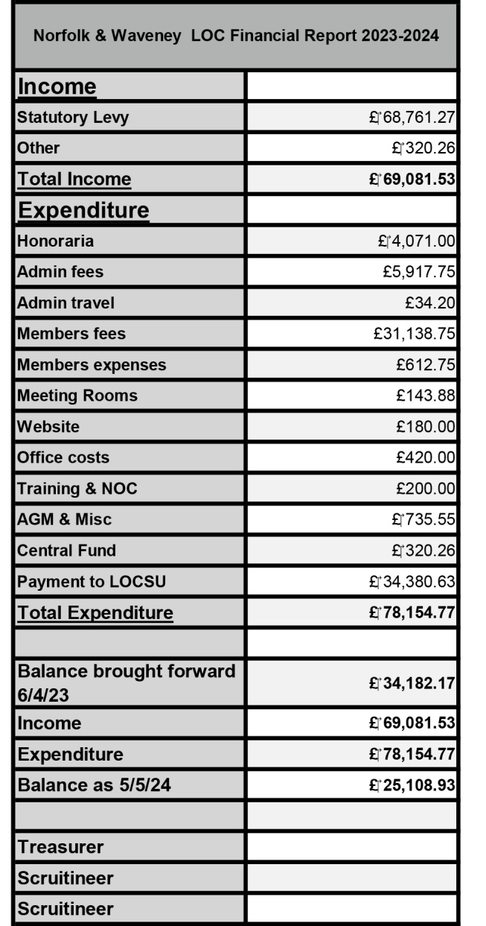Income from the statutory levy (0.5%) was higher than the previous few years (the highest it has been since April 2018-March 2019). Expenditure however was also higher than previous years. The costs associated with having a good representation at the National Optometric Conference costs were significant. The NOC was held in person near St Neots this time allowing several members to attend just for a day. Virtual committee meetings have continued keeping meeting costs down. The LOC now funds the locally provided CET since the demise of the LOA. The yearend showed a reduction in funds held as contingency but we still hold adequate funds.

LOCSU have once again not requested any change to the levy percentage they receive (currently 0.5%).

A short update from the Central Optical Fund (available on the website), which covered the cost of the last LOC wellbeing webinar - an offer that has been open to all LOCs in the country

Declaration of interest: I am a Central Optical Fund director for region 5 which includes Norfolk & Waveney.

Linda Vernon-Wood

Treasurer, Norfolk & Waveney Local Optical Committee

**Motion:** To allow the LOC to have the leeway to alter the levy between 0.4% and 0.9% allowing the Treasurer flexibility to respond to local developments.

**Proposed:** Michelle Horn: **Seconded:** Charlotte Berryman: **Motion passed**: Nem Con

**Scrutineers for LOC Accounts:** Rachel Adkins and Michelle Cave agreed to continue in the role.

1. **Central (LOC) Fund - A History of Support to the Optical Profession**

Founded by LOCs at the NOC in 1972, the Central Fund was established to finance work centrally on behalf of the profession and maintain a defensive reserve for the profession to defend it from attack and financial challenges. Today it still maintains that reserve and protects, promotes, develops and supports optometric interests through a system of grant awards for projects that benefit the profession

**LOC funded and controlled**

* The Central Fund is a company limited by guarantee that has LOC members who control it.
* Each LOC is entitled to be a member, there is no cost, and their liability is limited to £1
* The members appoint 5 directors, who are proposed and elected by LOCs at an Annual Meeting
* The Fund is accumulated by voluntary levies from contractors, donations from individual LOCs and Donations (and legacies) from individuals
* It is a not-for-profit organisation

## **What has the Central Fund ever done for us?**

For many years (up to the new OFNC) we funded NHS fee negotiations. We funded the setting up of the Optical Consumer Complaints Service and have provided funding support for numerous projects on behalf of ABDO, AOP, College and FODO. These include Legal Videos, The Foresight and Think Tank Projects and funding of political lobbying.

We funded the historic legal victory over HMRC securing partial exemption of VAT saving the sector vast sums of money. We funded the work to develop the enhanced eyecare pathways we now take for granted.

Our funding of cross sector projects has often enabled the profession as a whole to leap forward, such as the Quality in Optometry toolkit, the National Eye Health Epidemiological Model, The National Data Repository or the LOCSU Learning Disability pathway pilot.

We have supported research and learning by helping equip clinics as well as developing online courses and modules, masters programmes, 3D Virtual clinics as well as numerous research projects such as the Open Optometry free to all digital test chart.

We have supported public eye health messaging including projects with the Eyecare Information Service, support for Public Health learning, our long-standing support for Eye Health UK and National Eye Health week and recently the BCLA “Love Your Lenses” campaign.

## **Can anyone apply for funding**

The Fund invites and considers applications from individuals or organisations for funding optometry related projects. The Fund directors appraise applications based on the objects of the fund and award grants accordingly. Projects should increase the profile and expand the role of optometry by developing its scope and expertise. They should support the profession by developing resources, technologies and strategies that aid optometry and LOCs in particular. The Fund is particularly keen to encourage project applications from LOCs that are advancing the profession in this post COVID era.

## **Is there a place for the fund in The Future?**

There are many historic examples whereby we have provided cross sector funding, enabling the whole profession to progress. In the future it is likely there will be many more issues and opportunities which fall outside the remit or capacities of the separate optical bodies. In its unique position as able to benefit the whole of the profession, The Central Fund is therefore a resource that is not only useful to provide defensive funding at short notice, but also able to provide enormous impetus to change and advancement of the profession.

So please support us to protect, promote, develop and support optometry.

[www.centralfund.org.uk](http://www.centralfund.org.uk/)

1. **Committee Election**

The Constitution requires one third of the Committee members to retire each year; the members standing down this year are Charlotte Berryman; Ali Ganiwalla; Ian Sinha; each of these committee members has indicated their willingness to stand for re-election. A further committee vacancy remains unfilled.

There being no other nominations it was agreed that that all three are re-elected.

Mrs. Daplyn said she was happy to take questions later and closed the meeting at 19:55 hrs.

Signed………………………………………………..

Deborah Daplyn,   
**Chair Norfolk & Waveney Local Optical Committee**

Date……………………………